**Tab Navigation**

Installation:

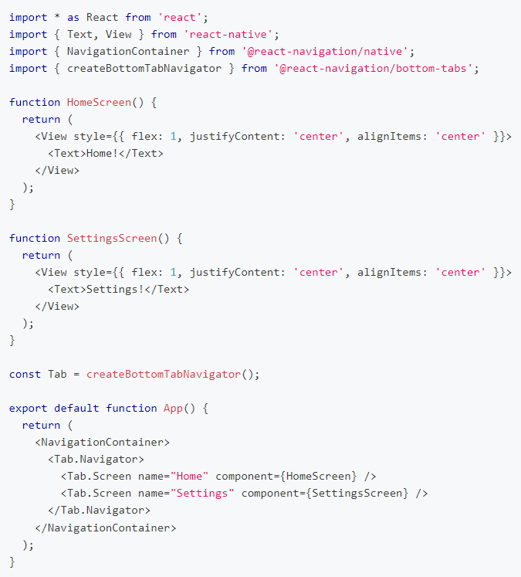npm install @react-navigation/bottom-tabs

**Drawer Navigation**

Installation:

Before continuing, first install and configure [@react-navigation/drawer](https://github.com/react-navigation/react-navigation/tree/main/packages/drawer) and its dependencies following the [installation instructions](https://reactnavigation.org/docs/drawer-navigator#installation).

npm install @react-navigation/drawer

npm install react-native-gesture-handler react-native-reanimated

To finalize installation of react-native-gesture-handler, add the following at the **top** (make sure it's at the top and there's nothing else before it) of your entry file, such as index.js or App.js:

import 'react-native-gesture-handler';

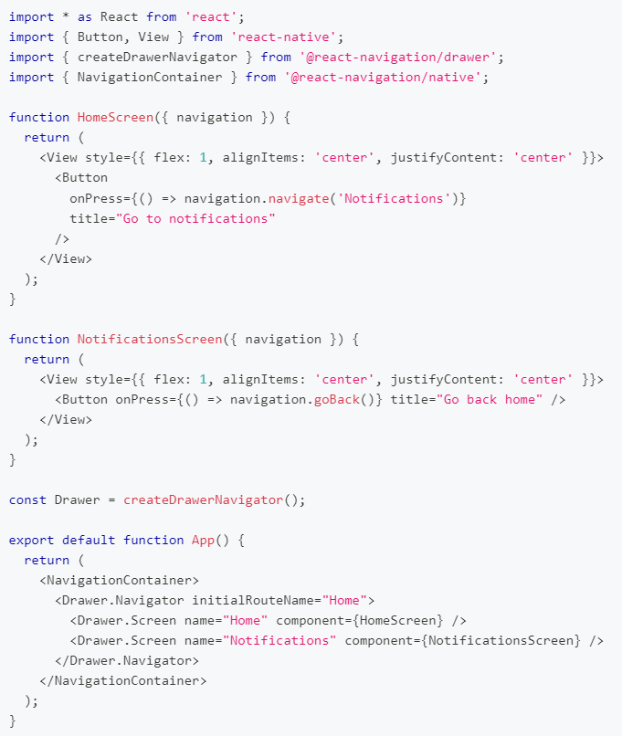Note: If you are building for Android or iOS, do not skip this step, or your app may crash in production even if it works fine in development. This is not applicable to other platforms.